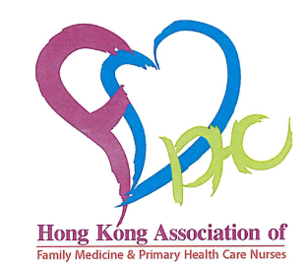

Diabetes Conversation Maps Tool Training Workshop
12 & 19 September, 2015
Objectives: The workshop is designated to equip the primary health care nurses with the relevant knowledge on diabetes, so that they would be able to understand the Diabetes Conversation Maps Tools (DCMT) to provide education to people with diabetes, and to empower them on behavior change & better self-management.
Date | : | 12 & 19 September, 2015 (Sat)
Time | : | 2:00pm – 5:30pm
Training Team :  : |  | Ms. HUNG Shuk -yee & Ms. Tina NG
Venue | : | Eaton Hotel, Jordan
Remark | : | Refreshment & Afternoon tea will be provided
Target  Participants : |  | Priority for members of Hong Kong Association of Family & Primary Health Care Nurses

Upon completion of the training, participants will be i) accredited with 3 CNE points for each class, ii) allowed to use the Map Tools to conduct patient sessions; iii) awarded a facilitator certificate provided that they have successfully conducted at least ONE DCMT patient session with at least three participants of the class within nine months after training, AND submit the session evaluation form.
For registration, please complete the reply slip and fax to 2572 7893 on or before 4th September (Fri). Registration will be considered on first come first serve basis. Successful applicants will be notified individual on or before 11th September (Fri) for confirmation of course acceptance. Please contact Ms Tina Ng at 9030 8709 if you have any enquiry
. …………………………………………………………………………………………………
♠ Reply Slip ♠
Please fax the reply slip to 2572 7893 (Attn: Ms. Tina NG)
Registration Information:
Name: ________________________________________ Prefix (circle one): Ms. / Miss / Mr.
Mobile Phone: ______________ Office Phone: _________________ Email: __________________
Post / Job Title: _____________________ Hospital / Affiliation: _____________________________
Delivery Address*: ________________________________________________________________
I have diabetes care / education experience □ No □ Yes, with ____ year(s)
*Please provide your office address for receiving the pre-works materials before the workshop

HKGHUM2015-01-22T10_47_17

